Landen Barber
10/30/25
Schedule Document Turn In

Three quarter Gantt chart
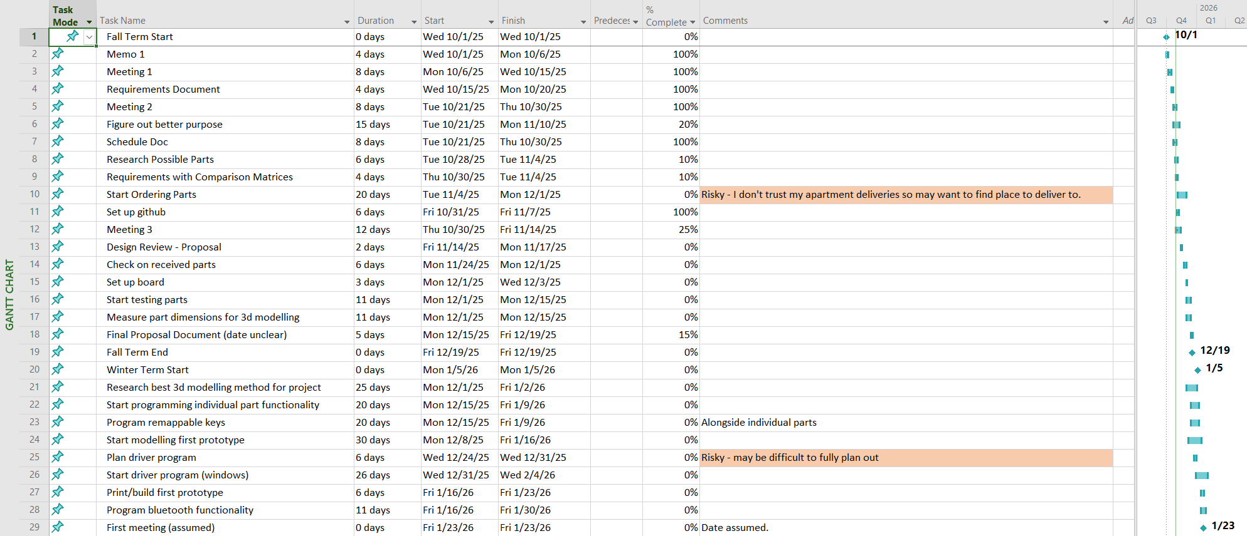
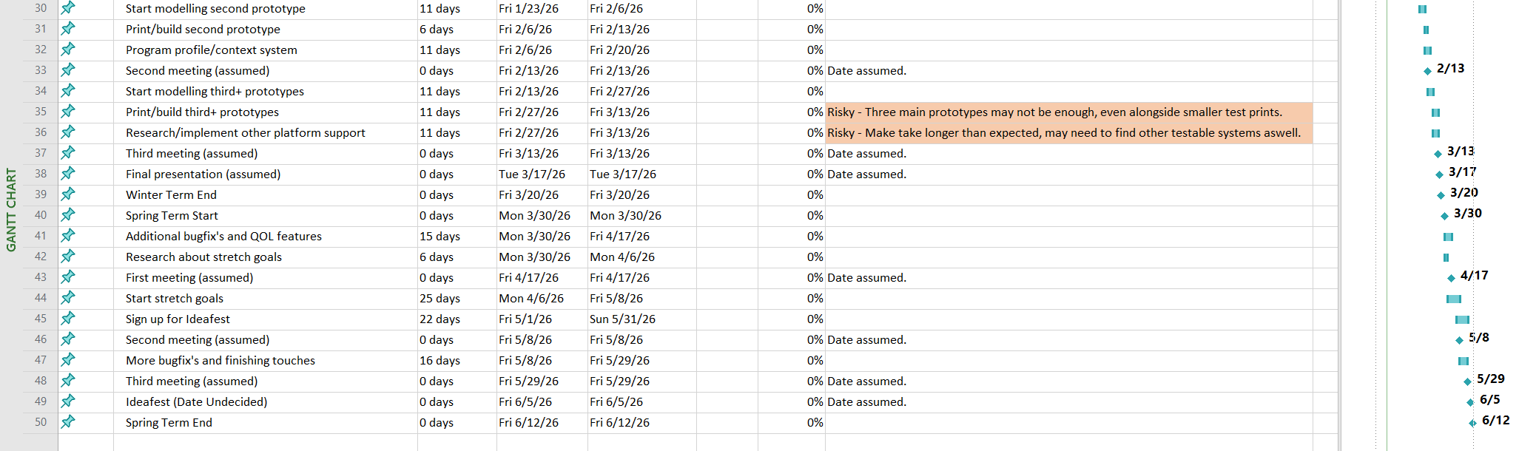

Sprint for fall term
